Terraform exercise



**GENERAL**in this exercise you will create AWS ngnix EC2 instance using terraform.  
  
Scripts content can be found in this URL:  
<https://github.com/eli2983/lectures/blob/master/Terraform_excersize>

**PREREQUISITED**

* OS: Ubuntu
* AWS Account

1. **Download Terraform executable**Terraform must first be installed on your machine. Terraform is distributed as a [binary package](https://www.terraform.io/downloads.html) for all supported platforms and architectures.   
   1. **Get Terraform executable**  
      If a newer version exists, please replace 0.11.7 with the new one.
   2. **Unzip Terraform executable**
   3. **Move Terraform executable to “/usr/local/bin”**  
      
2. **Create Terraform files (inside a dedicated folder)**
   1. **create terraform variable file (terraform.tfvars)**

replace access/secret keys and key path with your own AWS credentials:  
  


* 1. **create terraform file (terraform.tf)**
     1. Replace “key_name” variable default value with your AWS account default keypair name
     2. Make sure AWS VPC default security group allows inbound SSH & HTTP/s connections



1. Run “terraform init”

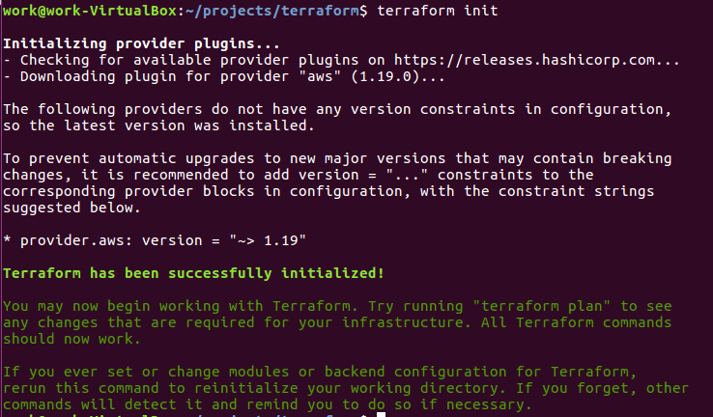

1. Run “terraform plan” command and check the output



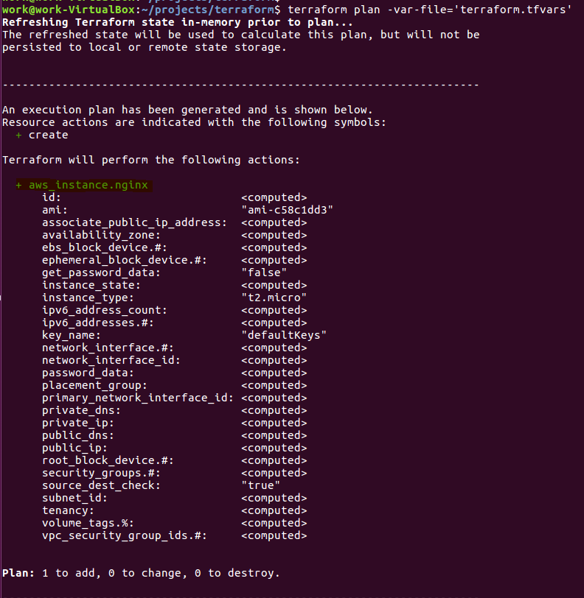

1. Run “terraform apply” command and wait for “Outputs”  
     
     
     
   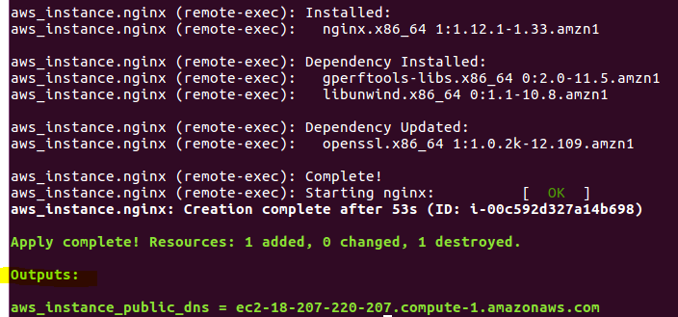
2. Browse to the new “ngnix” instance  
     
   